Sukkur IBA University

Software Design Specification (SDS)

For

MemDy

Entertainment App

Version [01]

Member #01: Rajesh Kumar

Member #02: Ghulam Hussain

Member #03: Imran Ali

Supervisor: Mr. Khalid Hussain Detho

Date: 22-03-2022

| Project Code | 18F-17 |
| --- | --- |
| Supervisor | Mr. Khalid Hussain |
| Project Lead | Ghulam Hussain |
| Project Team | Rajesh Kumar  Imaran Ali |
| Submission Date | 22-03-2022 |

Contents

1. Introduction
   1. Purpose of this Document
2. Entity Relationship Diagram (ERD)
3. Sequence Diagram
   1. Sequence Diagram for User Registration
   2. Sequence Diagram for User Login
4. Architecture Design Diagram
5. Database Diagram
6. Class Diagram
7. Interface Design
   1. Login Page
   2. Register Page
   3. Meme Creation Tool
   4. Profile Page
8. Introduction
   1. Purpose of this document

Purpose of this document is to provide a comprehensive diagramatic description of MemDy. It also provides a high-level design framework of the system which includes Entity Relationship Design, Database Design, architecture, Class Diagram, Sequence Diagram and Interfaces.

1. Entity Relationship Diagram (ERD)

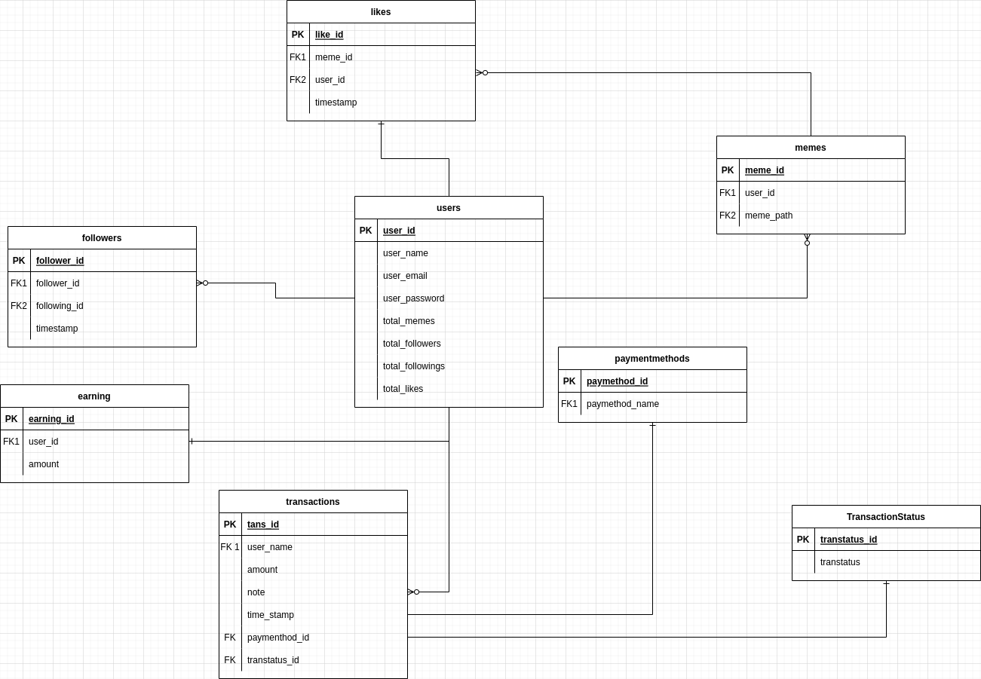

1. Sequence Diagrams
   1. Sequence Diagrams for User Registration

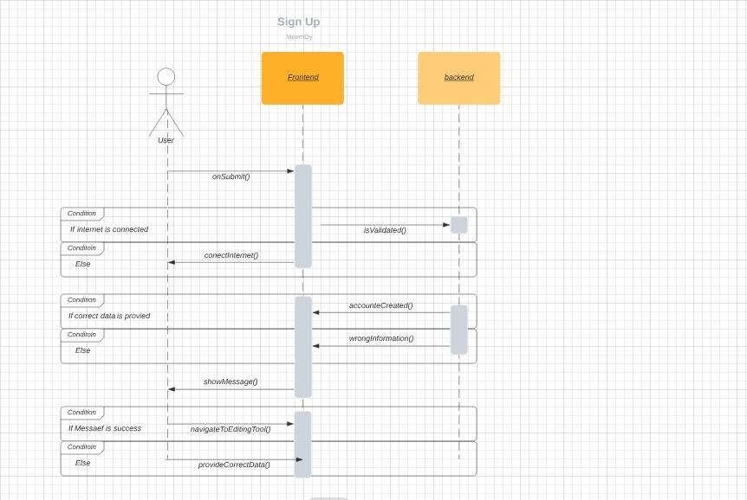

* 1. Sequence Diagrams for User Login

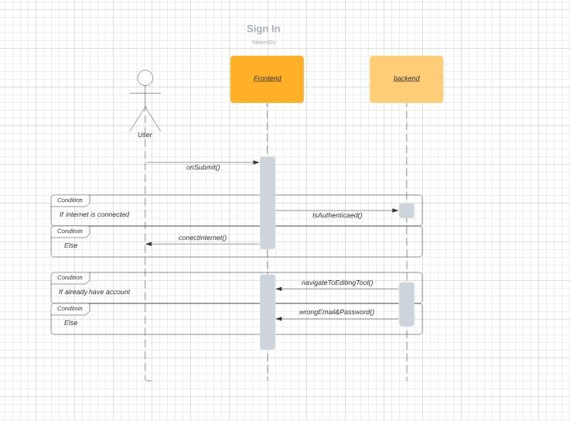

1. Architecture Design Diagram

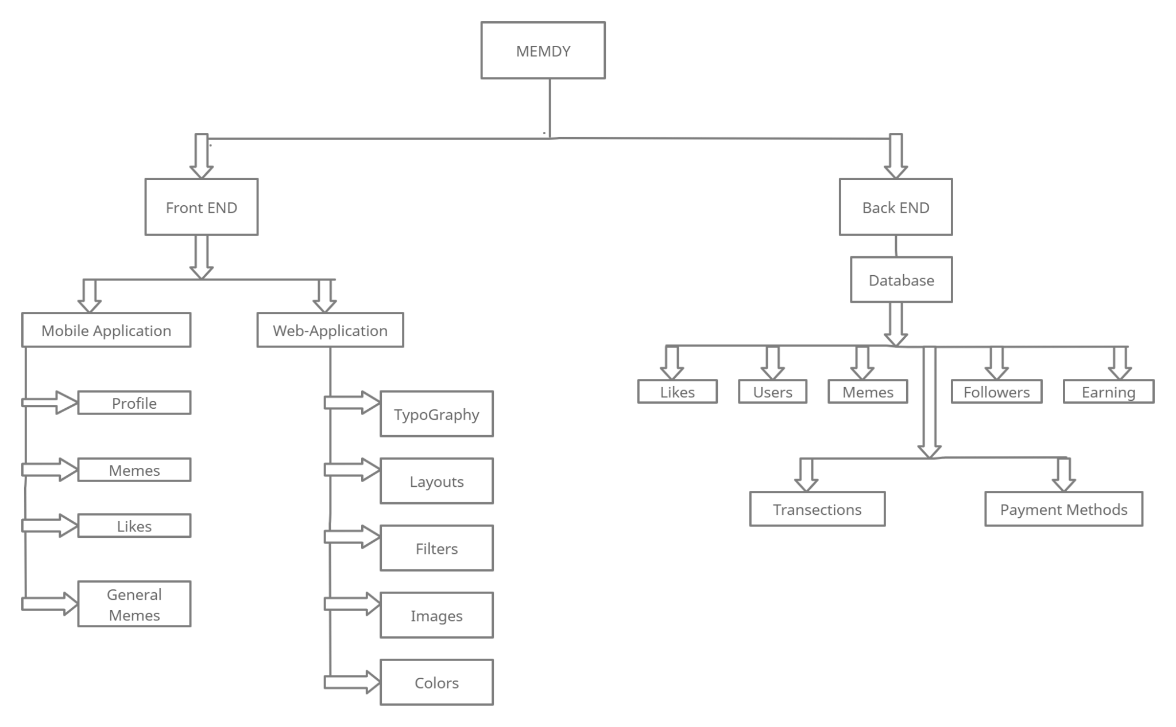

1. Database Diagram

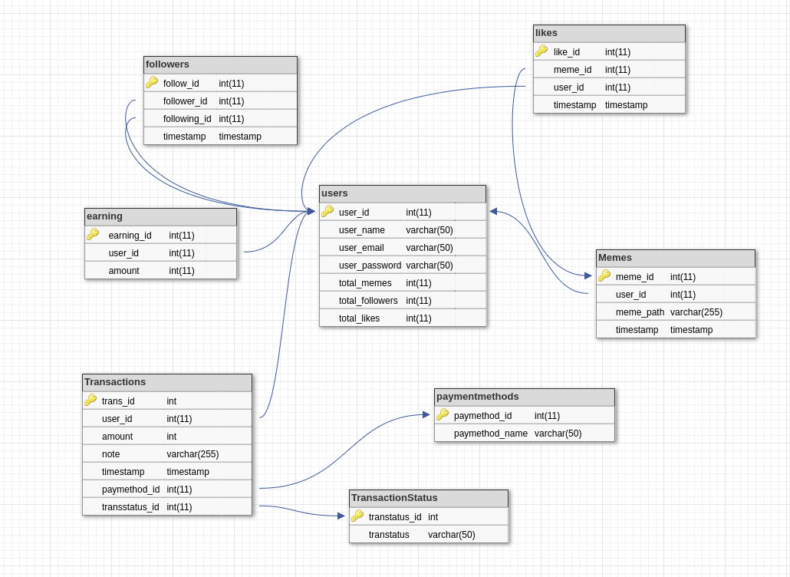

1. Class Diagram

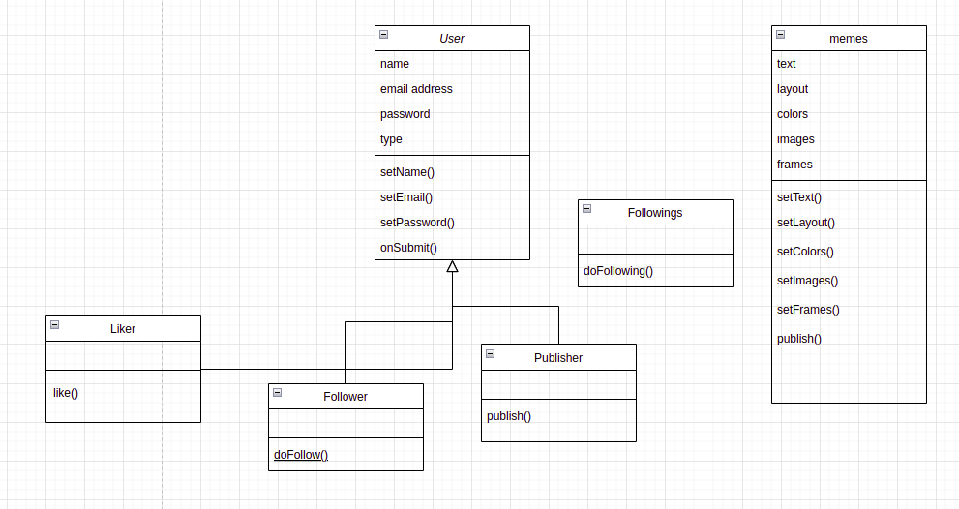

1. User Interface
   1. Login Page

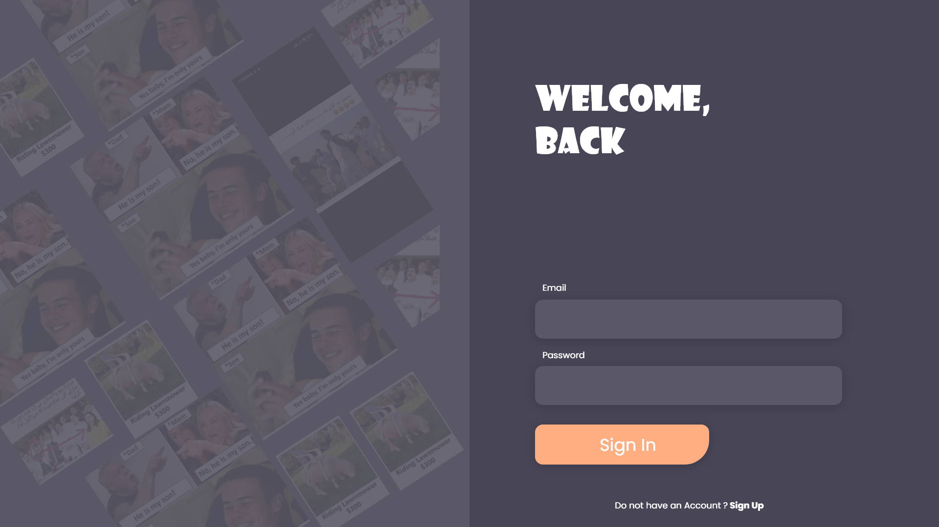

* 1. Registration Page

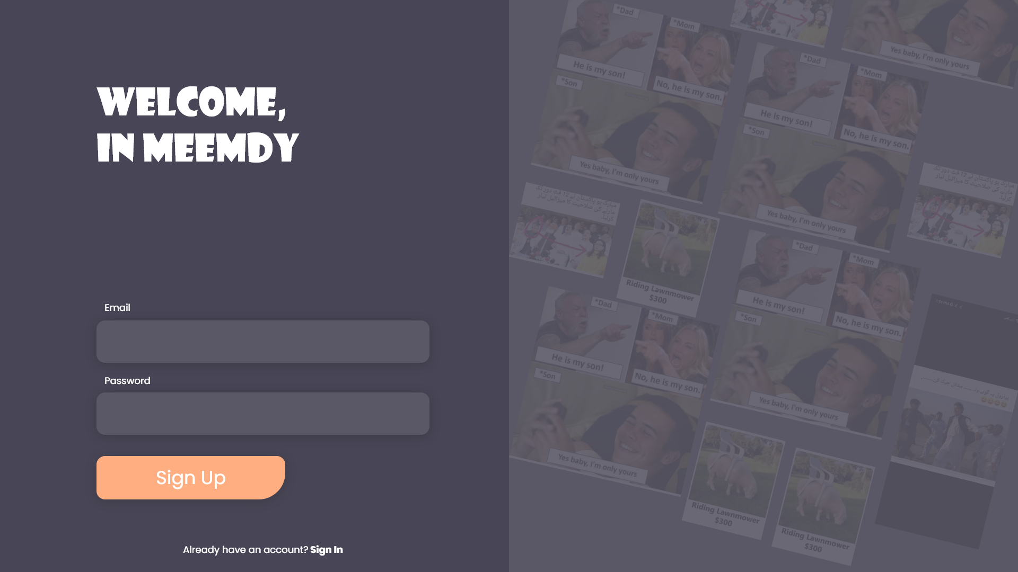

* 1. Meme Creation Tool

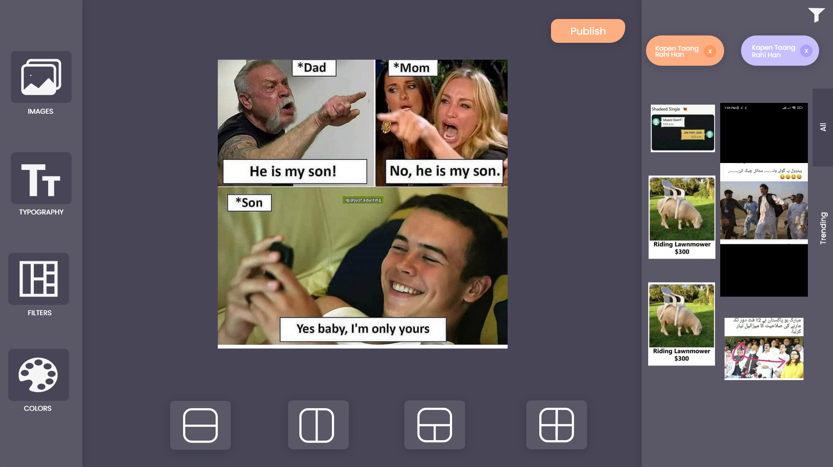

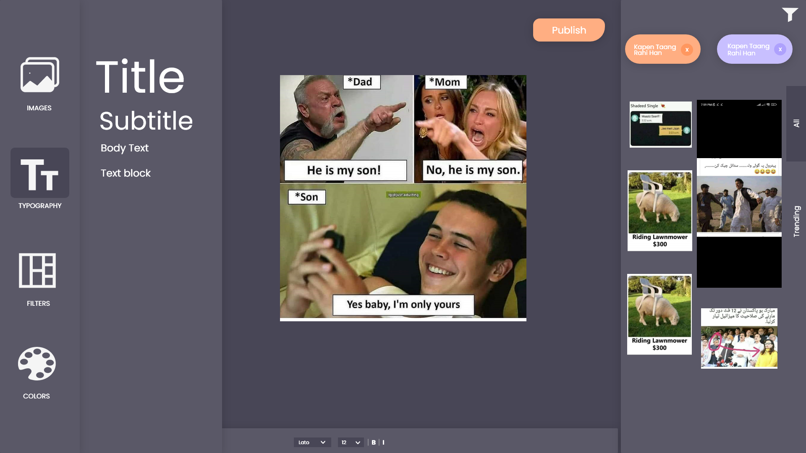

* 1. Profile Page

